<http://www.abc.net.au/news/2013-12-23/mysterious--hoseason-street-plaque-remembers-heroic-act/5165022>

Heroic act remembered through extraordinary coincidence

By [Clarissa Thorpe](http://www.abc.net.au/news/clarissa-thorpe/166966)

Updated 23 Dec 2013, 12:38pmMon 23 Dec 2013, 12:38pm

[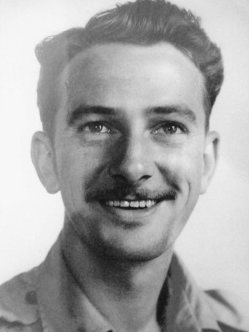**PHOTO:** Richard Hoseason was swept out to sea and never seen again.](http://www.abc.net.au/news/2013-12-18/aust-antarctic-expedition-member-richard-hoseason-died-1952/5165058)

[**MAP:**Mawson 2607](http://maps.google.com/?q=-35.3667,149.1(Mawson%202607)&z=5)

**It was an act of heroism in an icy wilderness near the bottom of the world a lifetime ago.**

But through an extraordinary coincidence its memory is kept alive to this day in a quiet suburban Canberra street.

Few who pass the inauspicious plaque on the verge realise the link with a young adventurer who died while trying to rescue a friend during an Australian Antarctic expedition.

Richard James Hoseason signed up to join a scientific trip to remote Heard Island as a radio operator in 1952.

His sister, Helen Powning, remembers a good-looking young man who saw an advertisement in the newspaper and headed south for adventure.

"He was planning to return and buy a house for his mother, but that never happened," she said.

The 27-year-old was walking along a beach at Corinthian Bay with two colleagues, Alistair Forbes (a Scottish dog trainer) and John Atkinson (a Queensland meteorologist), when tragedy struck.

A large wave pulled Mr Forbes off his feet and started washing him out to sea on the freezing tide.

The two others jumped into the water to rescue Mr Forbes, but Mr Hoseason was pulled further out into the ocean and was never seen again.

"They were wearing heavy oil skins to keep out the cold, and when they got wet it just weighed them down," Mrs Powning said.

Mr Atkinson and Mr Forbes survived and made it back to shore on another beach.

Mr Forbes immediately set off on foot to seek help but the ice-cold water had already taken its toll and he was later found dead on a nearby glacier.

Mr Atkinson made his way back to the main camp the next day suffering from frost bite and exposure.

Mr Hoseason's body was never recovered.

[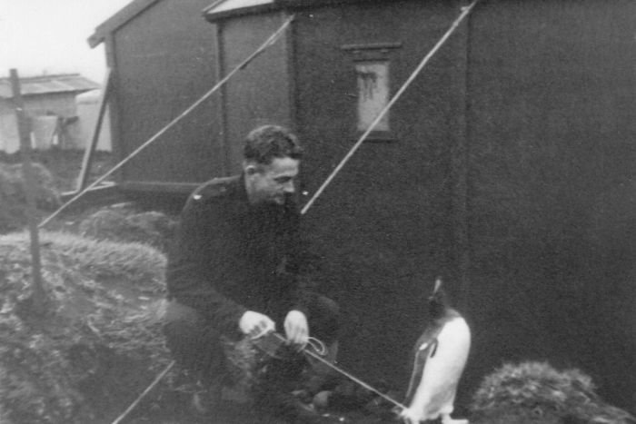**PHOTO:** Richard Hoseason during the Heard Island research trip in 1952.](http://www.abc.net.au/news/2013-12-18/richard-hoseason-with-a-penguin-taken-during-expedition/5165108)

Mysterious memorial plaque remembers Hoseason

Most of the streets in the suburb of Mawson are named after Antarctic explorers and their related expeditions, including Hoseason Street.

[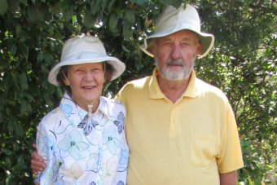**PHOTO:** Hoseason Street residents Pat and Eric Pickering have been looking after the plaque for years.](http://www.abc.net.au/news/2013-12-18/mawson-residents-pat-and-eric-pickering/5165102)

And there the memory of that heroic act 60 years ago may have remained, marked by just another street sign in just another suburb.

But in a remarkable twist, Hoseason Street became home to a former technical officer and radio operator on Antarctic expeditions in the 1960s.

Stephen Grimsley had heard the sad story from colleagues and in the 1970s he organised for a plaque to be quietly added to the nature strip to remember the tragic loss.

Even Mr Hoseason's family was unaware of the plaque for 20 years.

Today Mr Grimsley's former neighbours, Eric and Pat Pickering, help maintain the unofficial plaque at the southern end of the street.

"It is still there today for people to see," Mrs Pickering said.

"It gets covered up occasionally and when we walk past we pull out the odd weed."

A large glacier on East Antarctica has also been officially named after Mr Hoseason.

[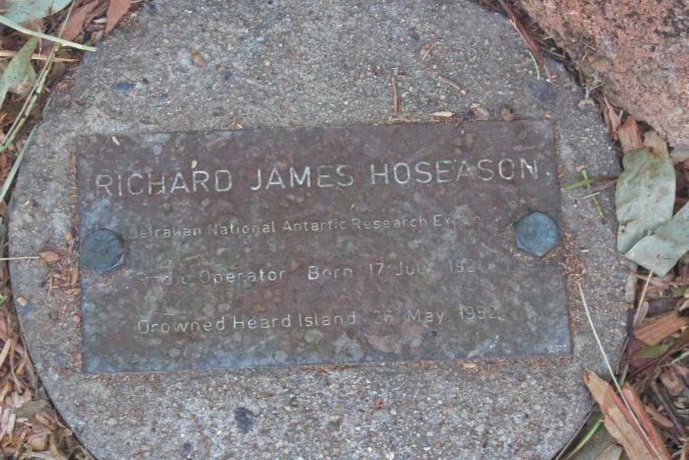**PHOTO:** This simple plaque appeared mysteriously 40 years ago at the southern end of Hoseason Street.(ABC News: Clarissa Thorpe)](http://www.abc.net.au/news/2013-12-18/memorial-plaque-in-hoseason-street/5165098)